St Anthony’s High School, Faisal Town
Book List 2026 – 2027
Class 8A
Subject | Text Books | Note Books
Islamiat | - Punjab Text Book Board 8 | 1 Single Line Large Size Copy (60 Leaves)
Ethics | 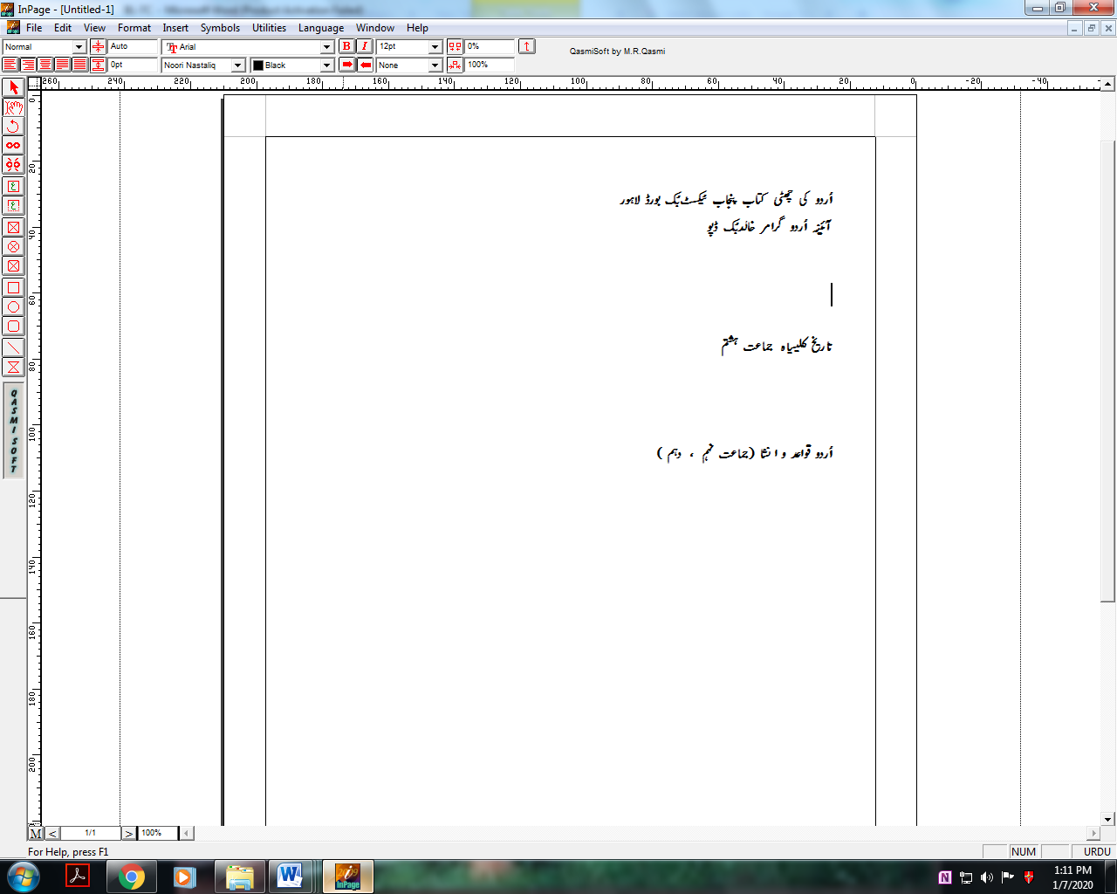
English | - Wren and Martin  Middle School English Grammar and Composition (by Paramount)  - Tales from Shakespeare by Charles and Mary Lamb (Puffin Classics) | 3 Single Line Large Size Copies (60 Leaves)
Urdu | - Urdu for class 8 by PCTB  - 10-9 اُردو قواعدِ و اِنشا | 2 Broad Line Large Copies (80 Leaves)
Mathematics | - Mathematics 8 by PCTB | 2 Single Line Large Size Copy (80 Leaves)
Science | - Science for class 8 by PCTB | 3 Interleaf Single Line Large Size Copies  (60 Leaves)
S-Studies | - Geography for class 8  By PCTB  - History for class 8  By PCTB | 2 Interleaf Single Line Large Copies  ( 80 Leaves)
Computer | - Punjab Text Book Board 8 | - Single Line Large Size Copy  (60 Leaves)
Note:
- All the books have been selected according to the availability to avoid inconvenience for the parents.
- Only school copies covered with plastic cover are allowed
- No trolley bags and fancy stationery is allowed.
- Pirated books are not allowed.

